## 



SRI LANKA INSTITUTE OF INFORMATION TECHNOLOGY

[Enterprise Standards and Best Practices for IT Infrastructure](http://courseweb.sliit.lk/course/view.php?id=137)

**4thYear 2nd Semester 2016**

**Assignment – 01**

**Lab 01 -** Creating an Amazon EBS-Backed Windows AMI

**Lab 02 -** Creating an Amazon EBS-Backed Linux AMI

**Lab03 -** Creating a MySQL DB Instance and Connecting to a Database on a MySQL DB Instance

## Dewindi U.K.A

## IT13023942

## WEEKEND IT

**Lab 01 -** Creating an Amazon EBS-Backed Windows AMI

### Step1

Create an Amazon account using credit or debit card. And login to the aws account using username and password. Select EC2 from Amazon Web Services. (Services -> EC2)

### Step2

Click on Launch Instance under Create Instance fromEC2 Dashboard.

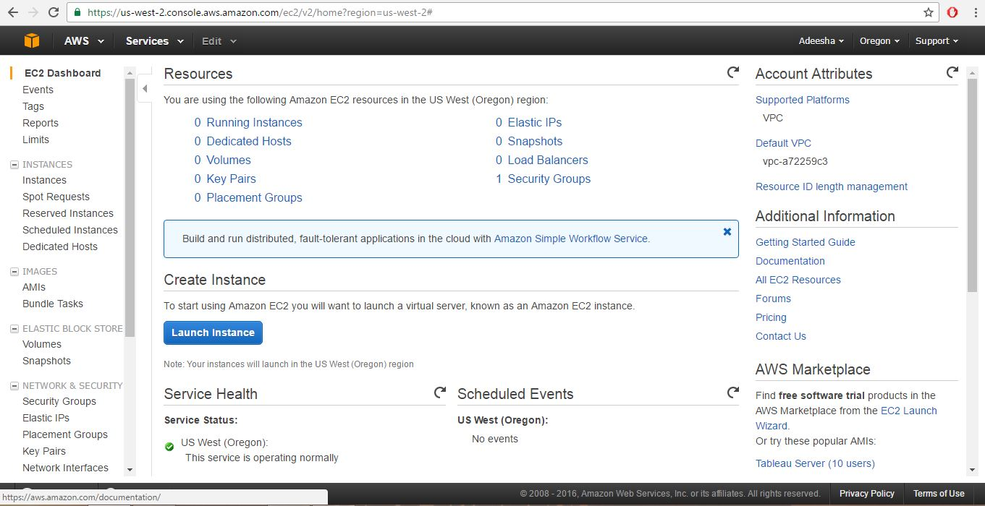

* **Step3**

Choose a AMI as Microsoft windows server R2Base.

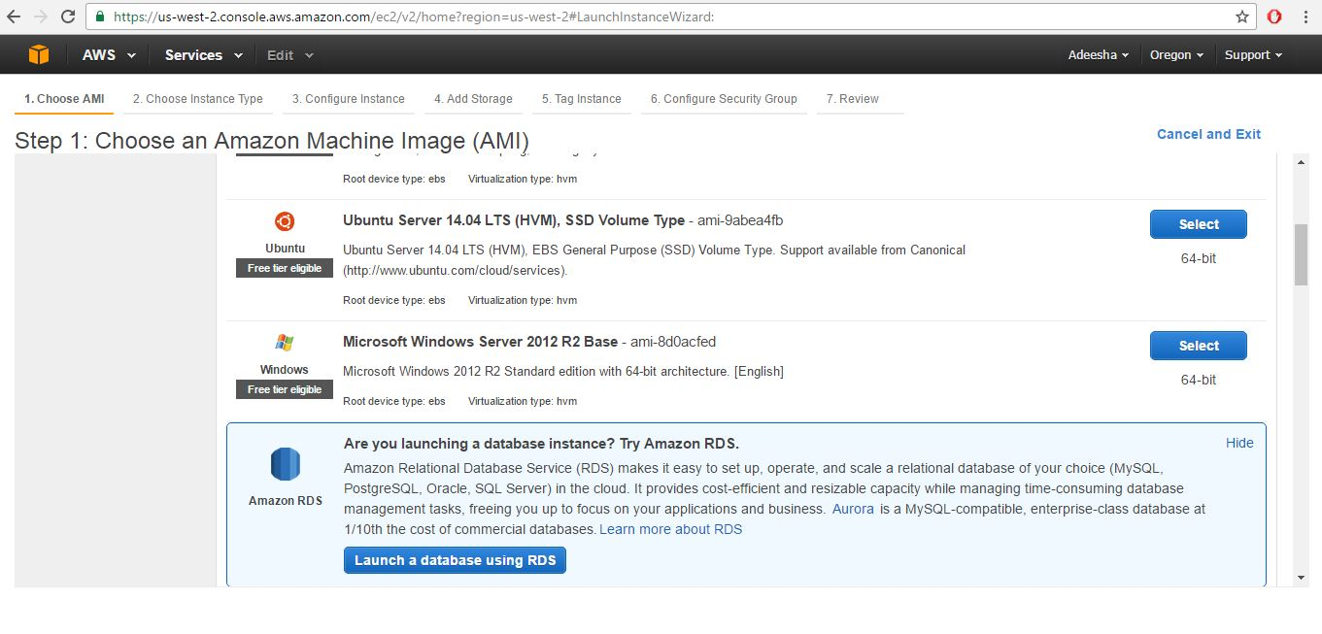

* 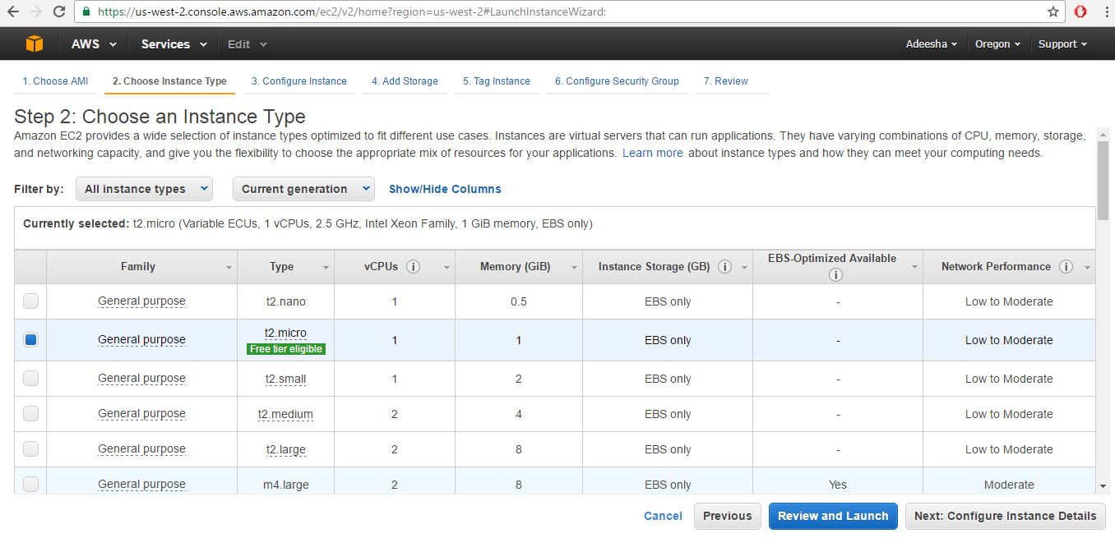**Step4**

Choose an Instance type. Keep it as default one. Then click review and launch button.

* **Step5**

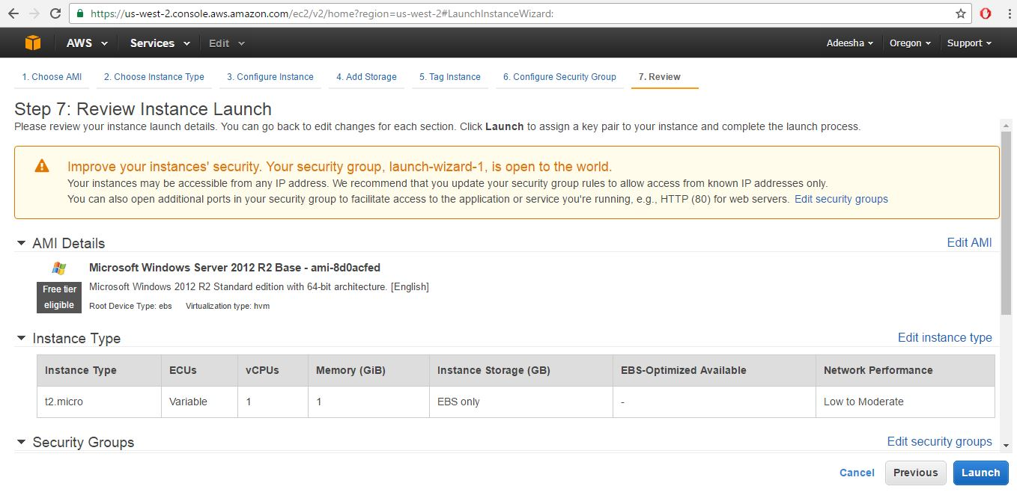Launch the selected review instance.

* **Step6**

Create a new key pair download a new key pair. Then give a key pair name.

Then select Launch Instance.

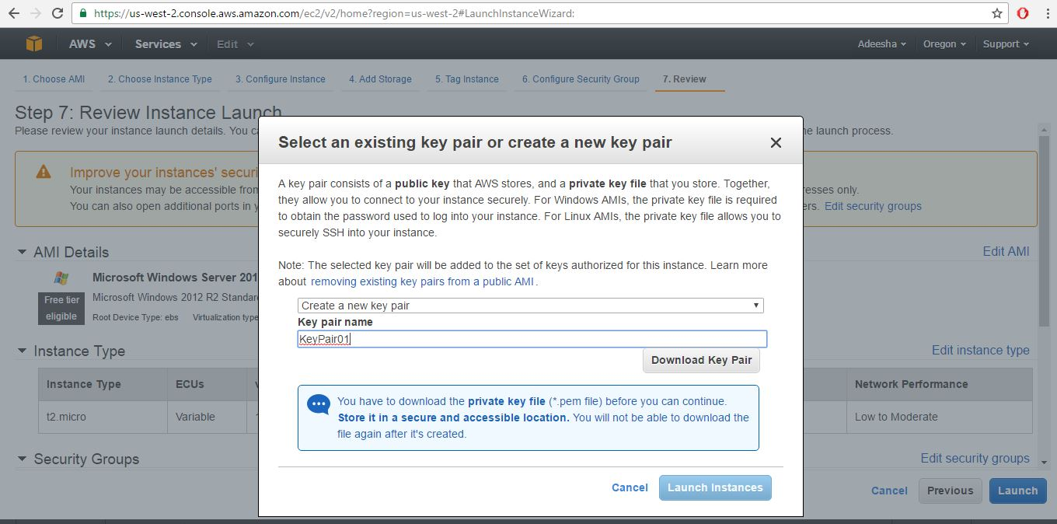

* **Step7**

View Instances after launching.

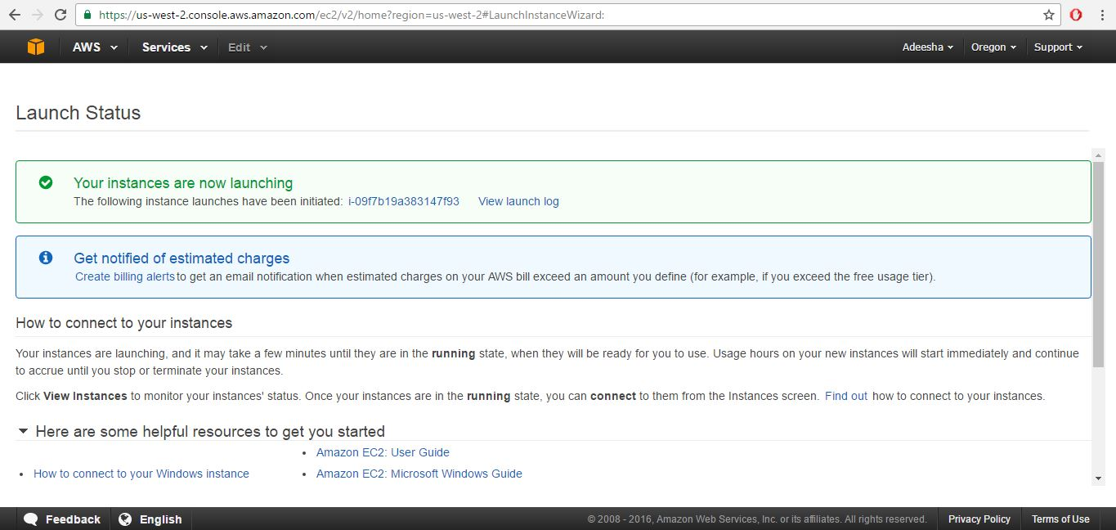

* **Step8**

Select the created instance and then connect.

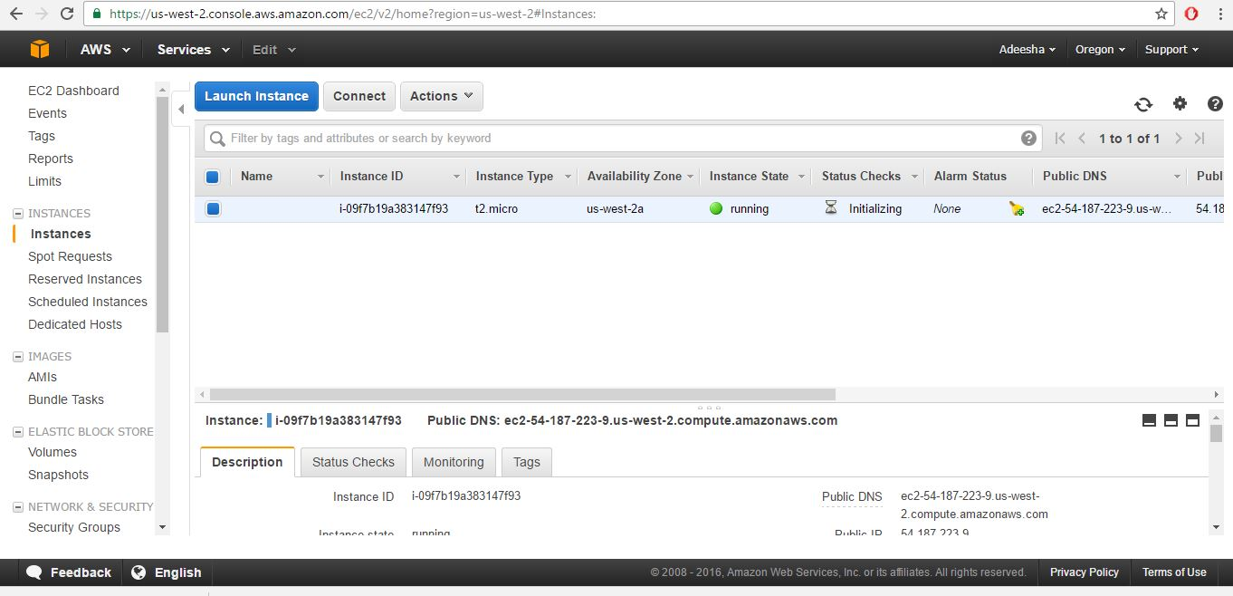

* **Step9**

Get a password from Connect to Your Instance tab.

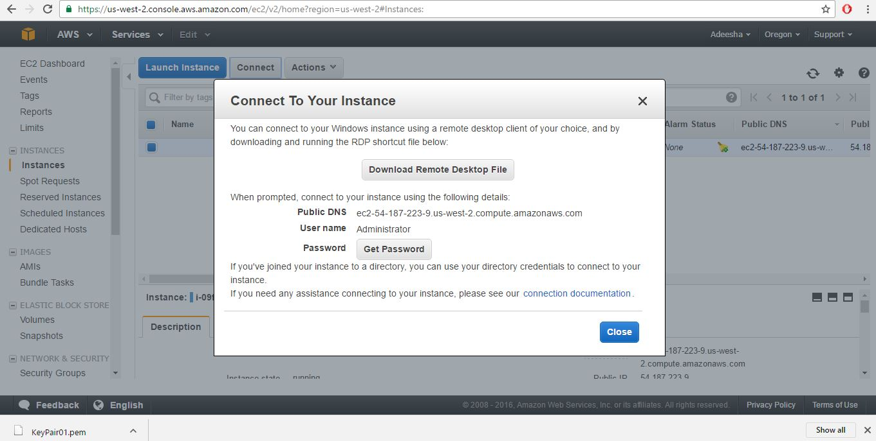

* **Step10**

Decrypt the password.

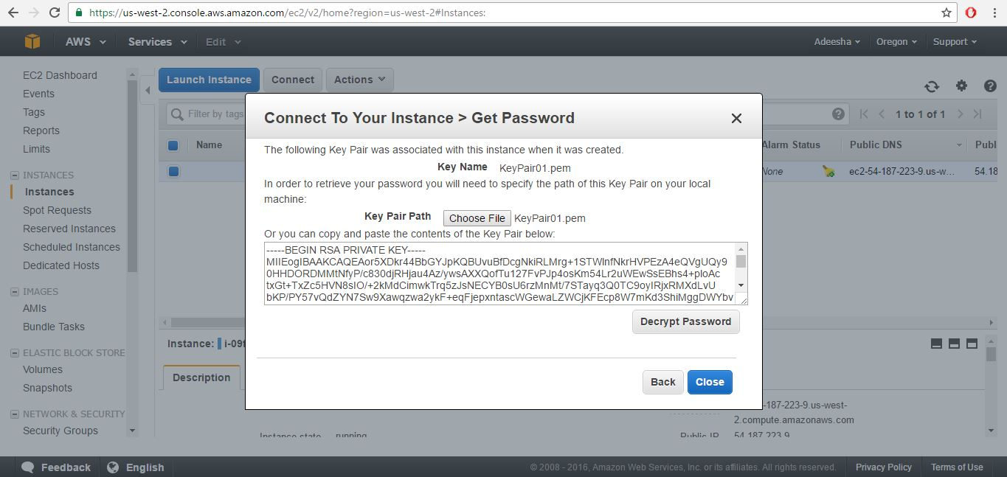

* **Step11**

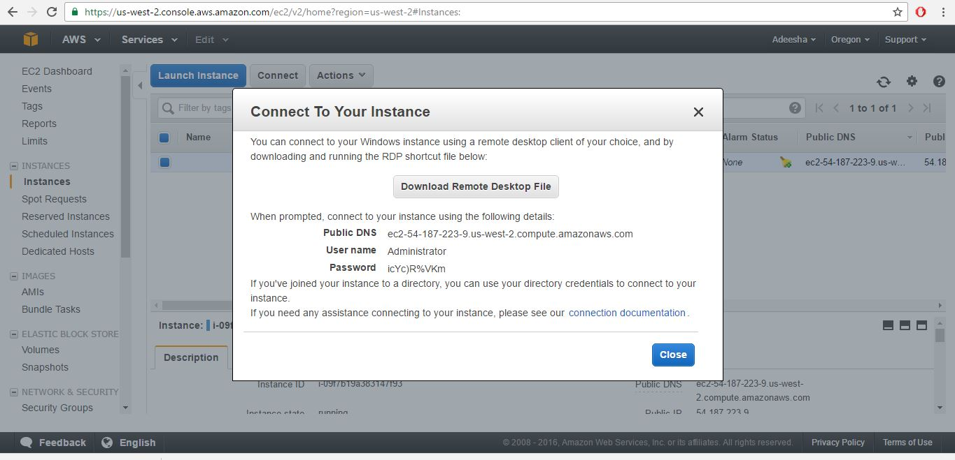

* **Step12**

Open Remote Desktop Connection. Type the public IP of the launched instance.

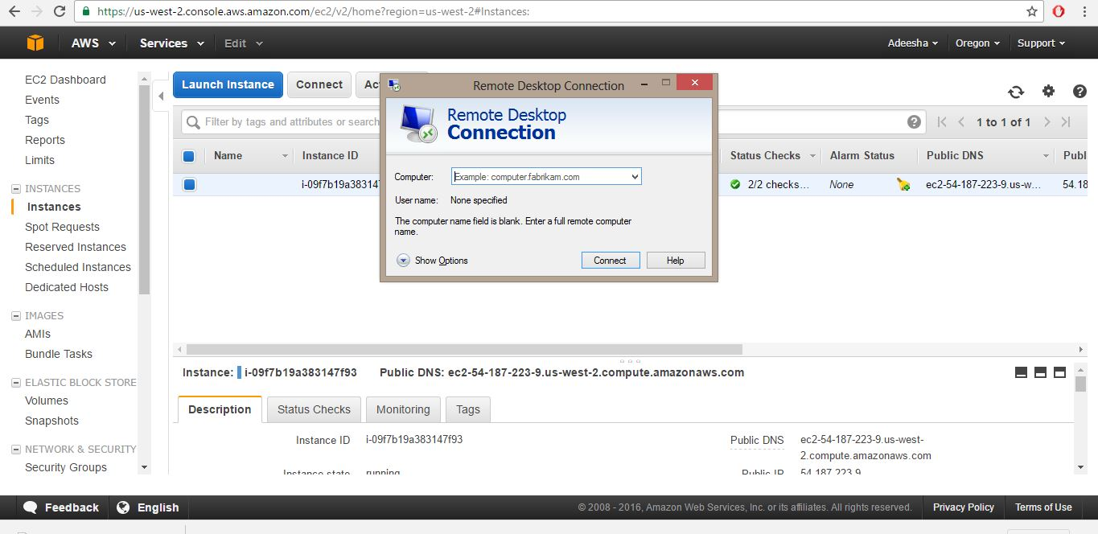

* **Step13**

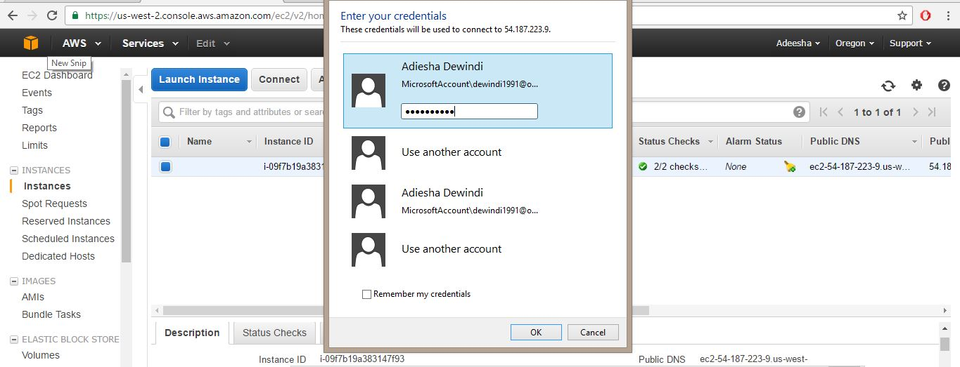

* **Step14**

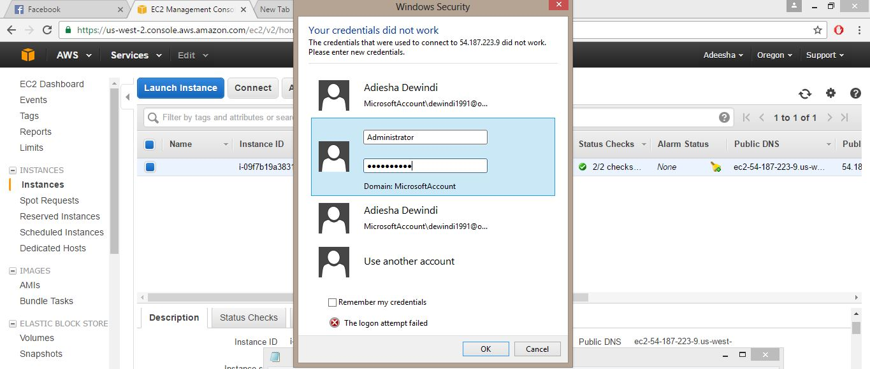

* **Step15**

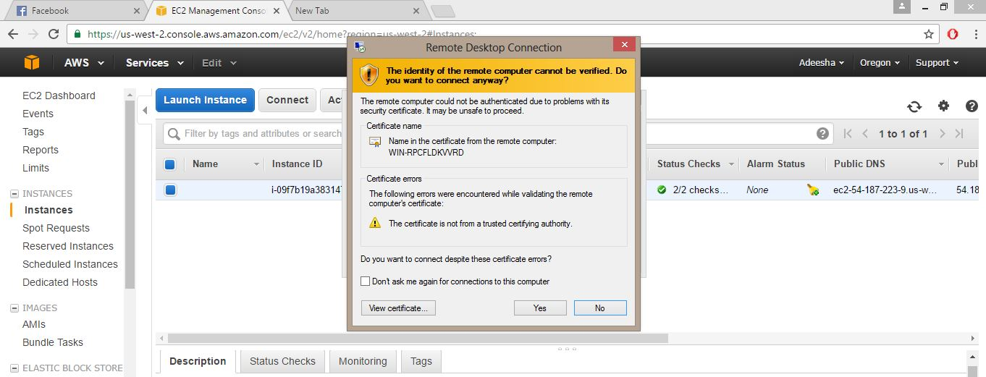

* **Step16**

Log in to Windows Server 2012 R2 using the given user name and the decrypted password.

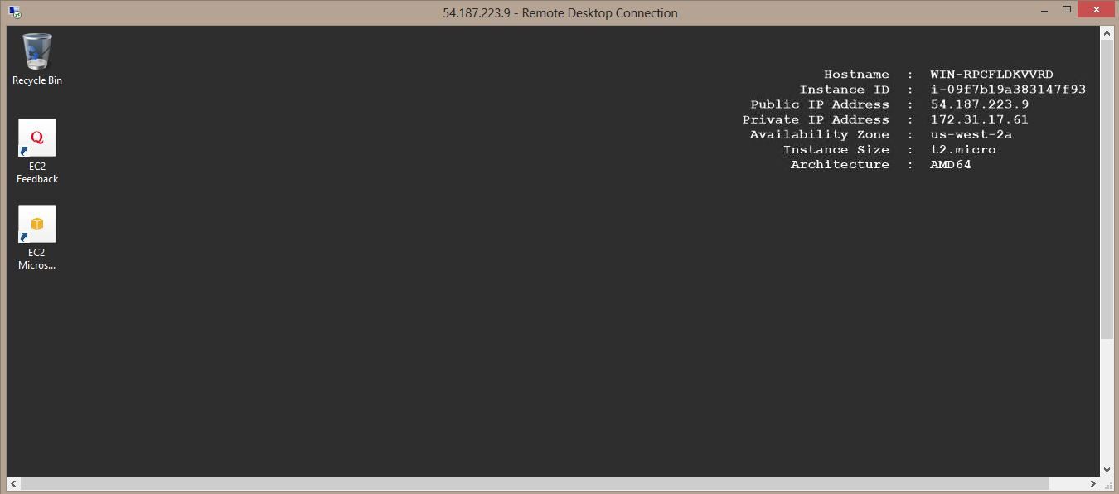

* **Step17**

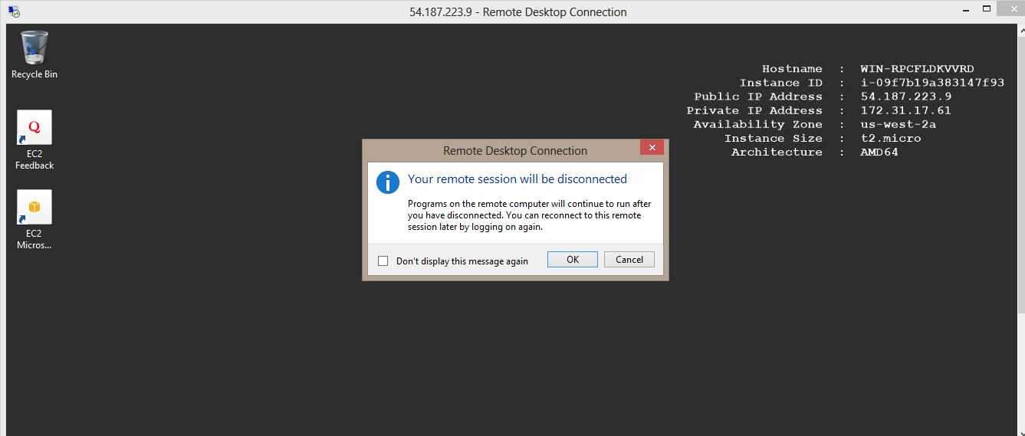

* **Step18**

Right click your running instance. Then click terminate.

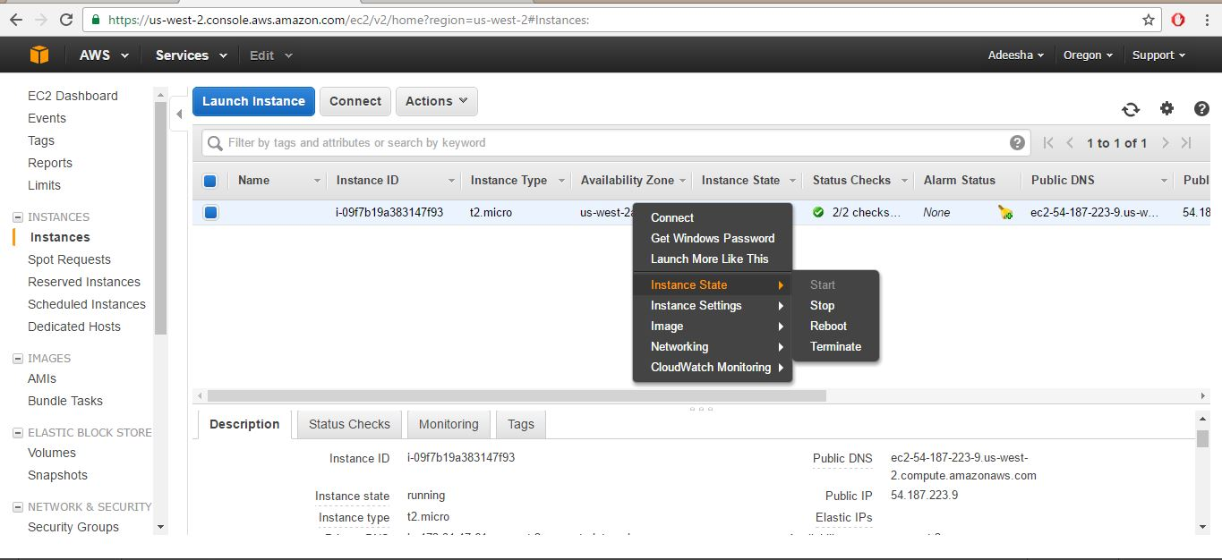

* **Step19**

Then instance is terminated.

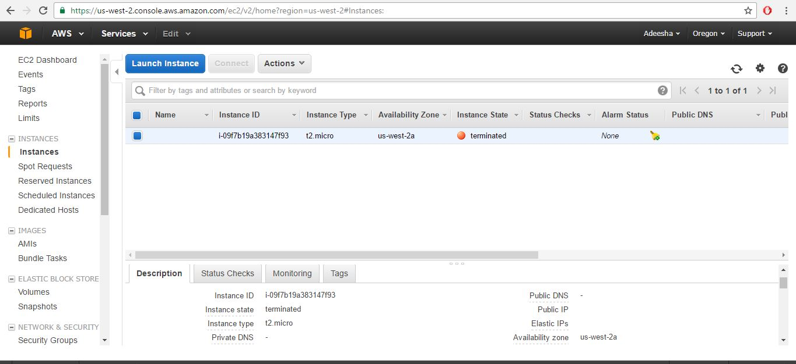

**Lab 02 -** Creating an Amazon EBS-Backed Linux AMI

* **Step 01**

Select EC2 from Amazon Web Services. (Services -> EC2).

Select Launch Instance under Create Instance fromEC2 Dashboard.

Select an Amazon Machine Image (AMI). Select Amazon Linux AMI 2016.03.3 (HVM), SSD Volume Type.

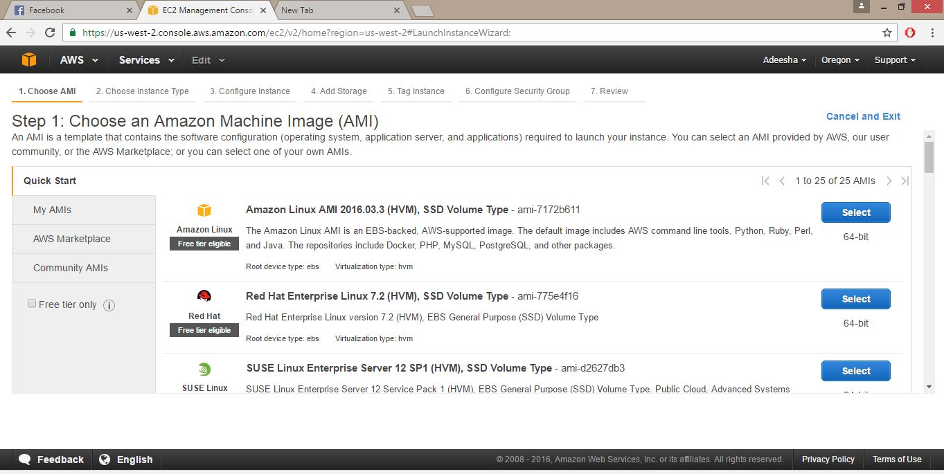

* **Step 02**

Choose an Instance Type. Then review and launch.

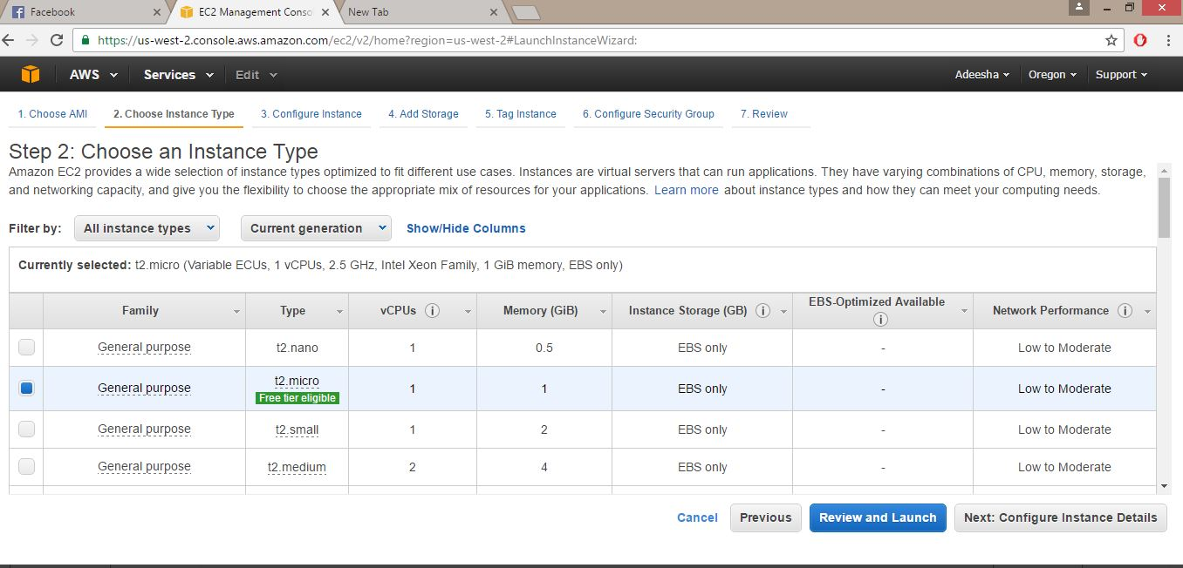

* **Step 03**

Review Instance Launch.

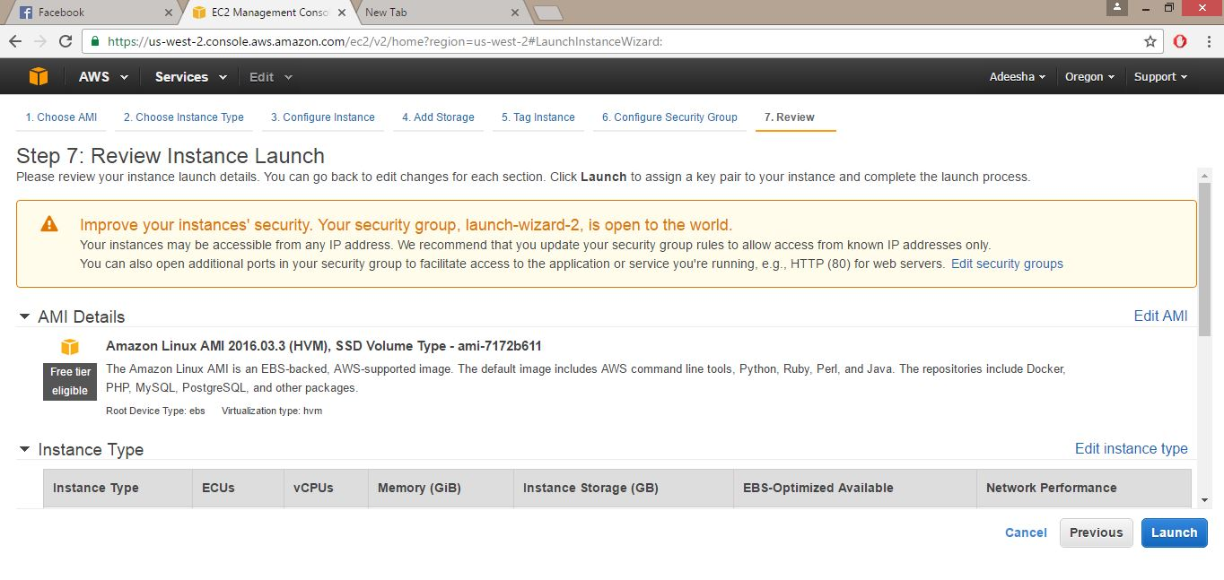

* **Step 04**

Choose create a new key pair to download a new key pair. Then give a key pair name.

Then select Launch Instance.

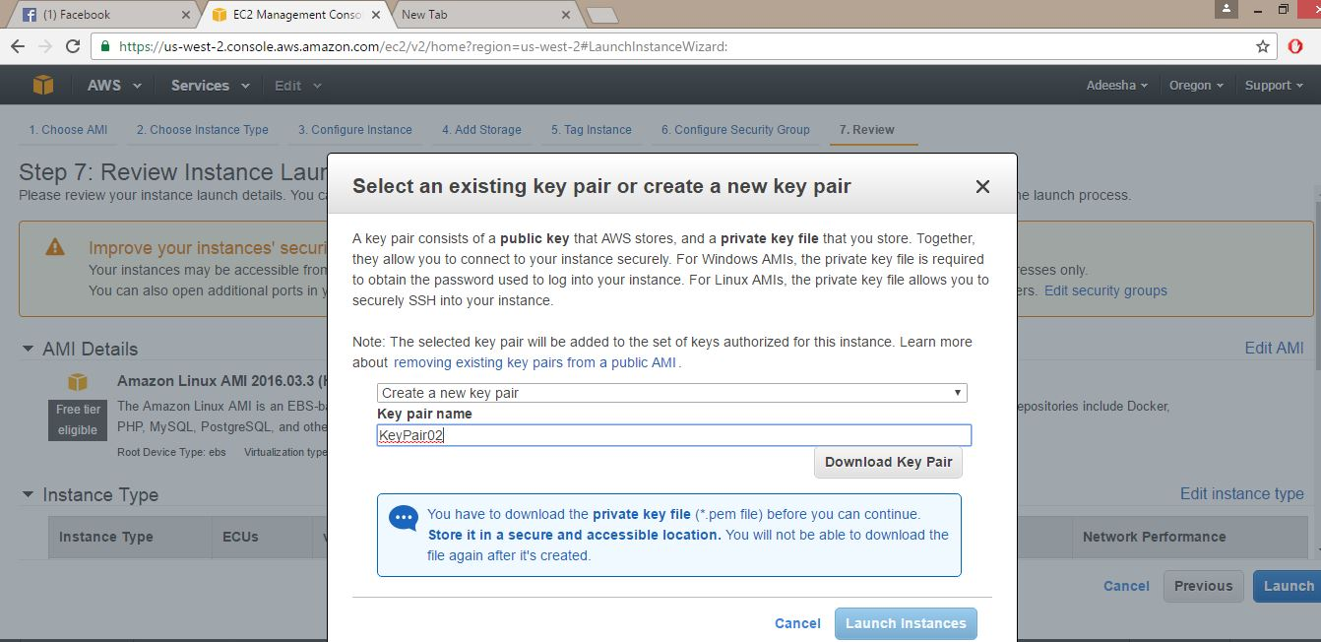

* **Step 05**

View Instances after launching.

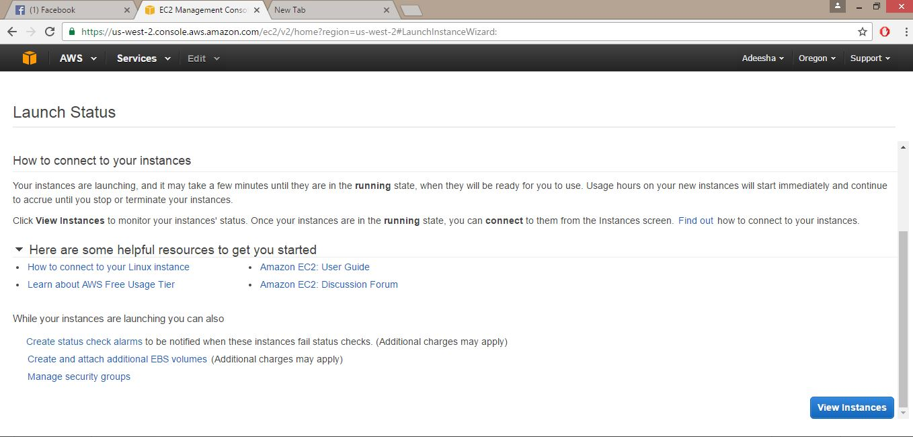

* **Step 06**

Open PuTTY Key Generator. Then browse and load the downloaded key pair file and save it as a private key.

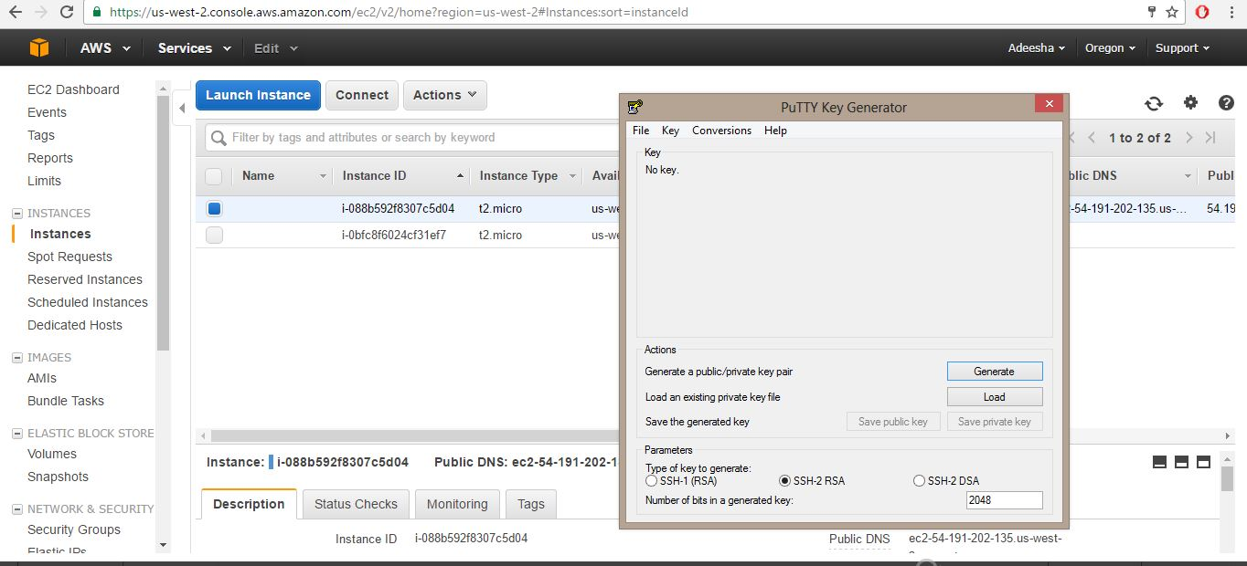

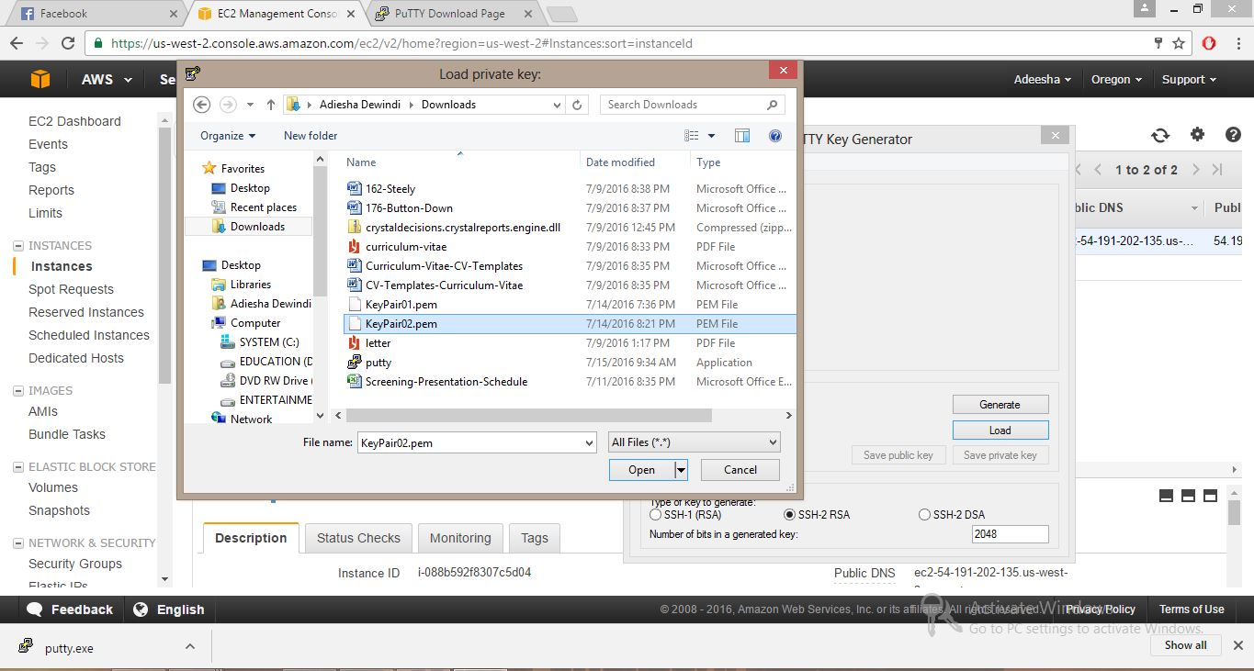

* **Step 07**

Open PuTTY Configuration.; Go to Connection category for SSH authentication. (Connection -> SSH -> Auth)

Then under authentication parameters browse saved private key and open.

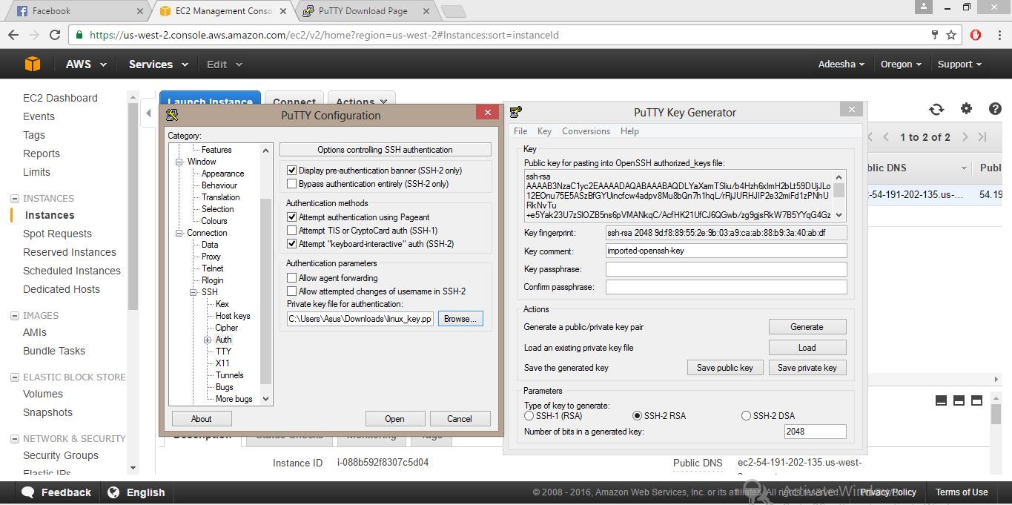

* **Step 08**

Go back to Session category in PuTTY Configuration.

Copy the Public DNS of created instance and paste it under Host Name. Set Connection type to SSH and open

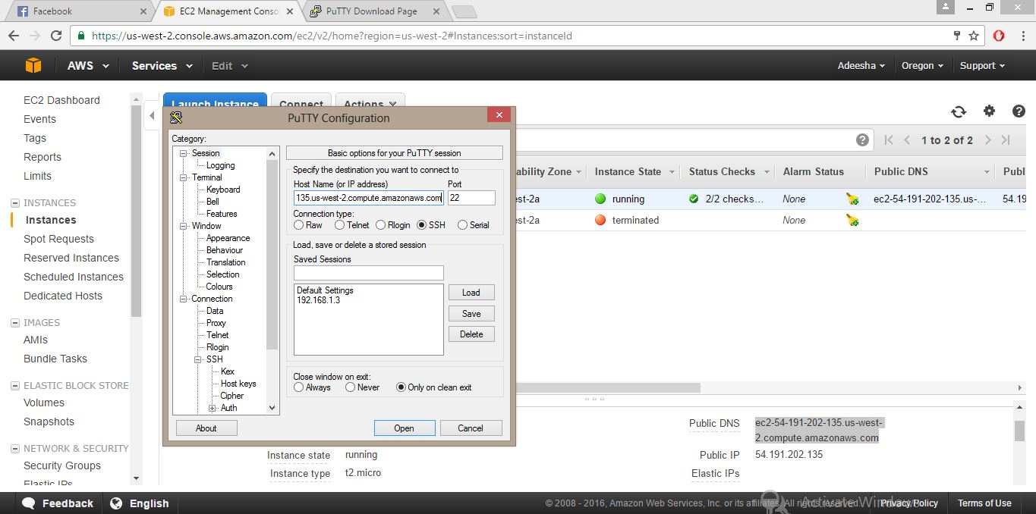

* **Step 09**

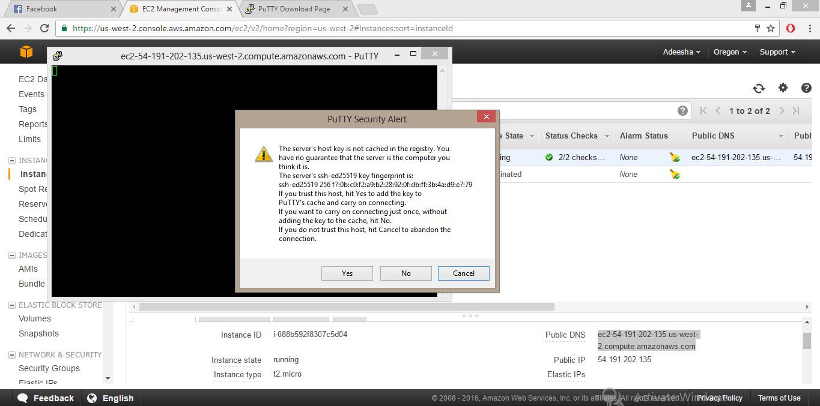

* **Step 10**

Log in to Linux by giving user name as (ec2-user).Then type some Linux commands to check. As (ls -al)

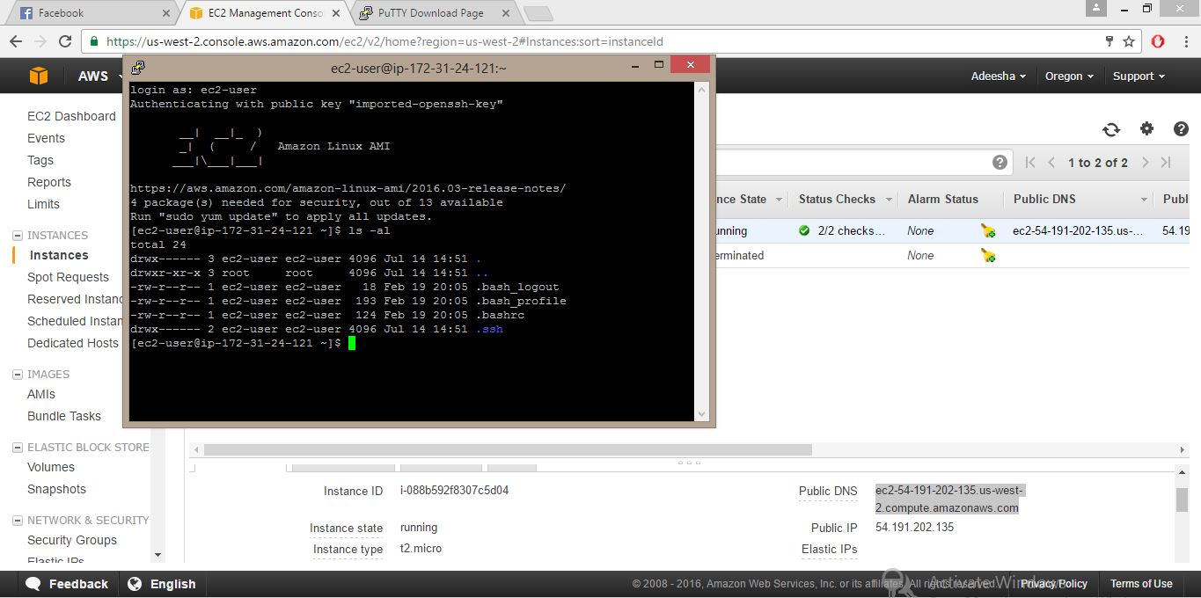

* **Step 11**

For terminate or stop the instance from instance state.

(Right click on instance ->Instance State ->Terminate/ Stop)

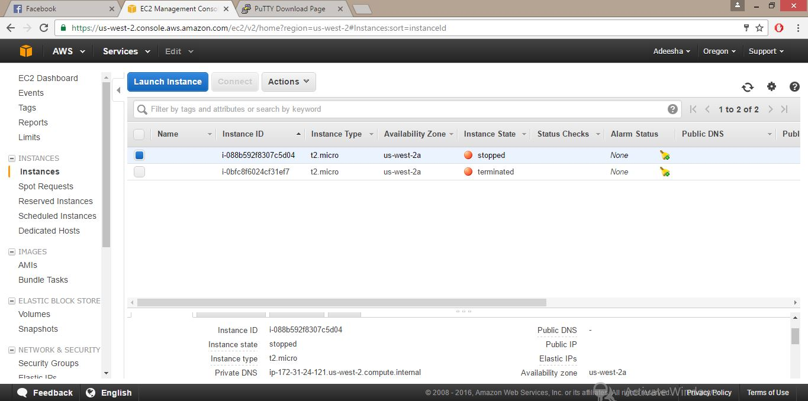

Lab 03- Creating a MySQL DB Instance and Connecting to a Database on a MySQL DB Instance

* **Step1** – Select **Amazon RDS from amazon web services. Click get start now button.**

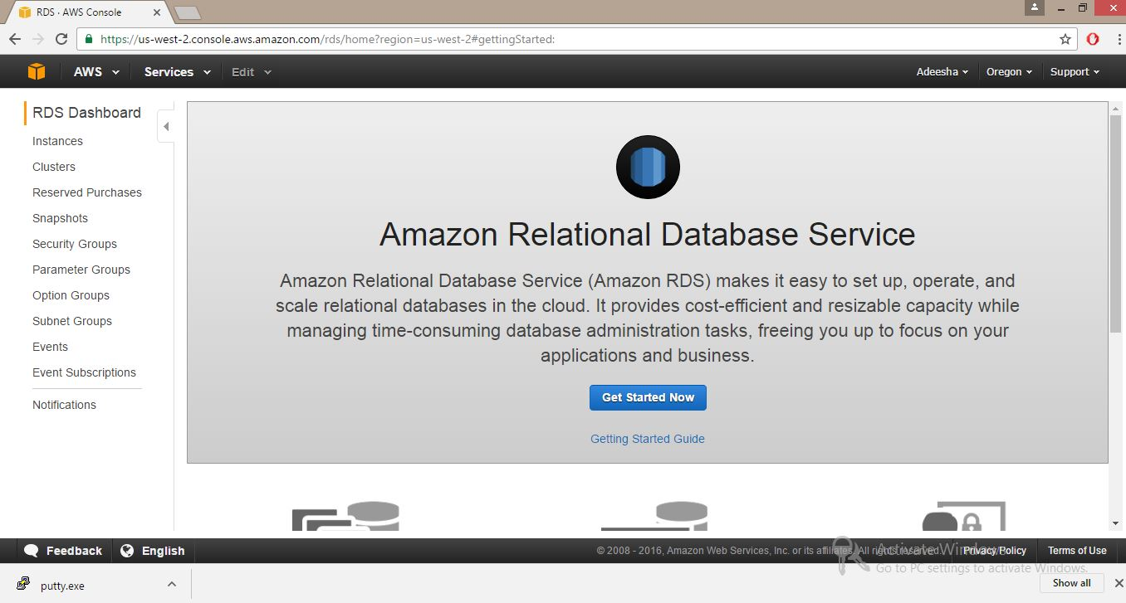

* **Step2**

Create DB Subnet group

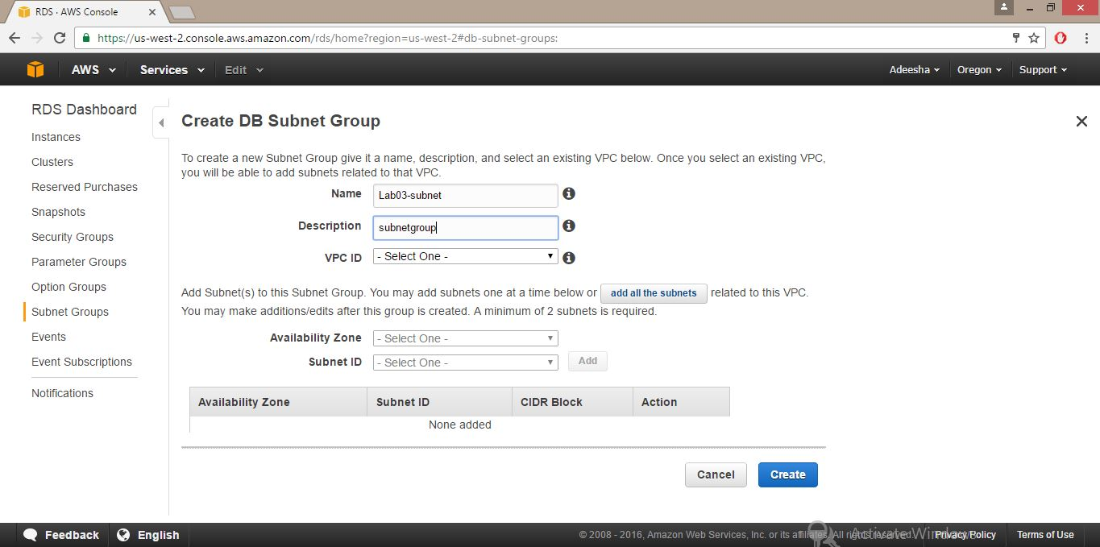

* **Step3**

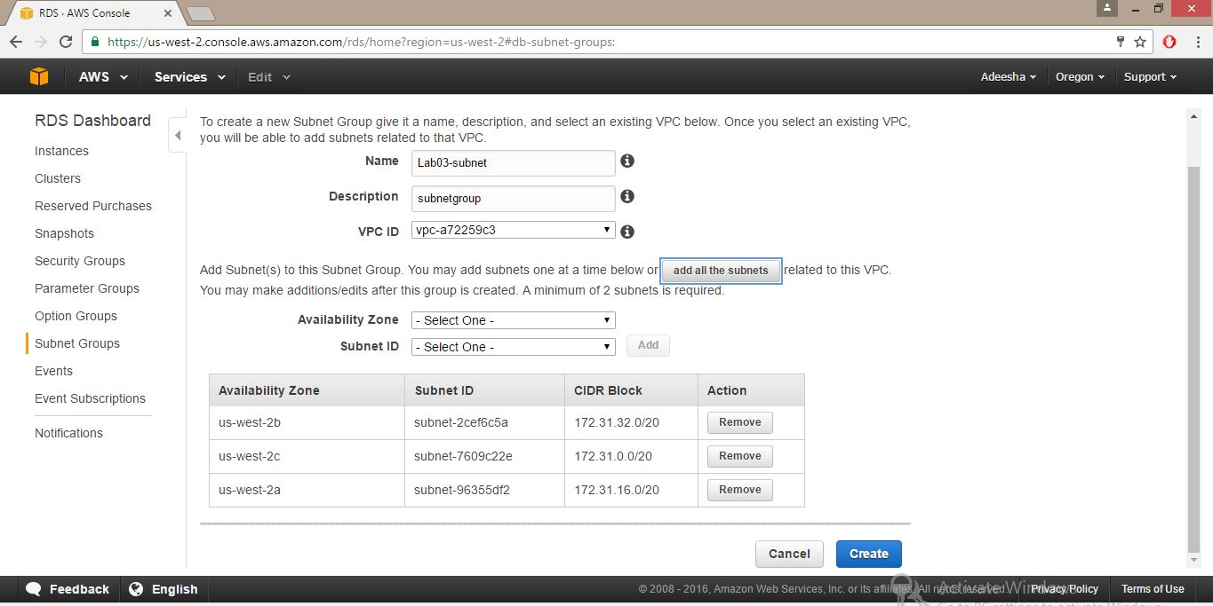

* **Step 4**

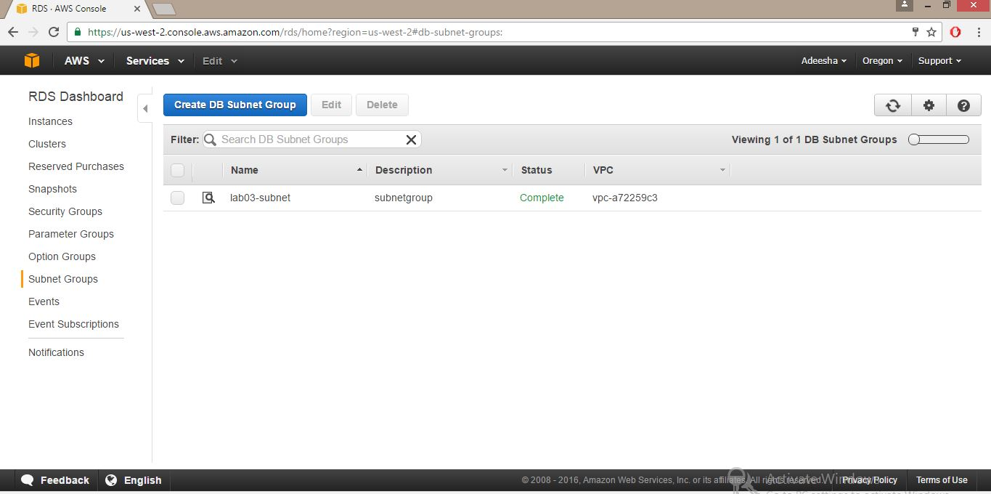

* **Step 5**

In Select Engine page, choose the MySQL icon and then choose Select for the MySQL DB engine.

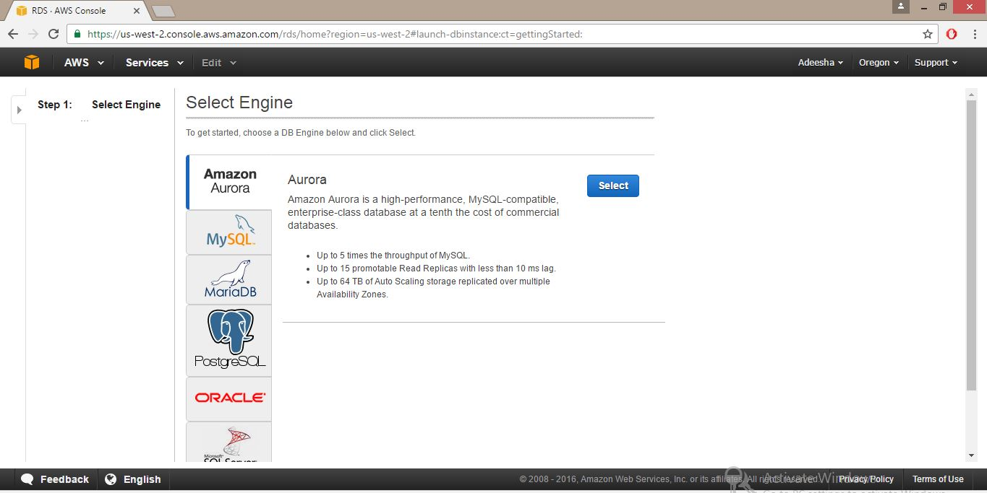

* **Step 6**

On the production page, when the settings are as you want them, choose next step.

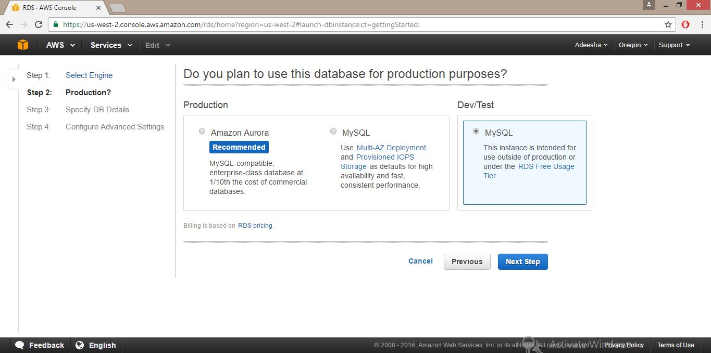

* **Step 7**

On the Specify DB Details page, specify your DB instance details.

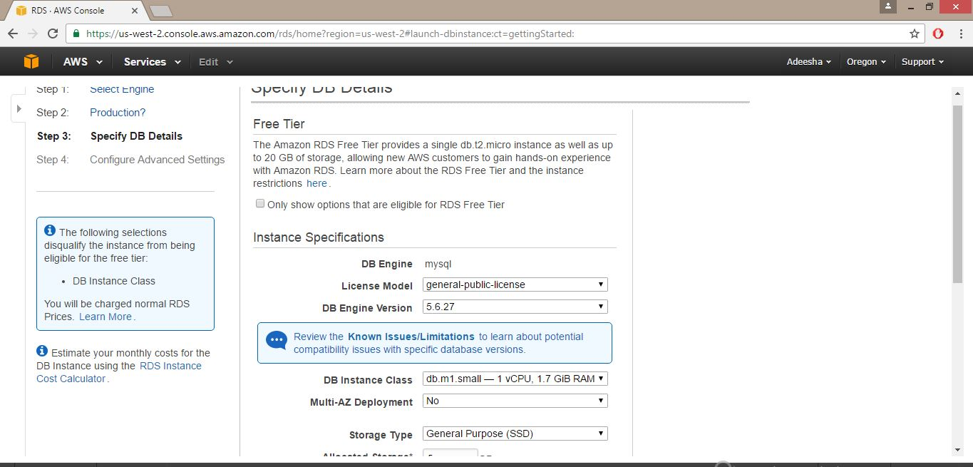

* **Step 8**

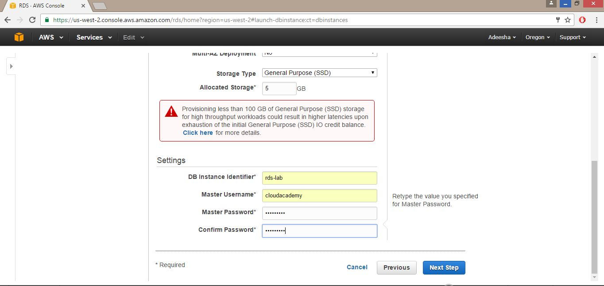

* **Step 9**

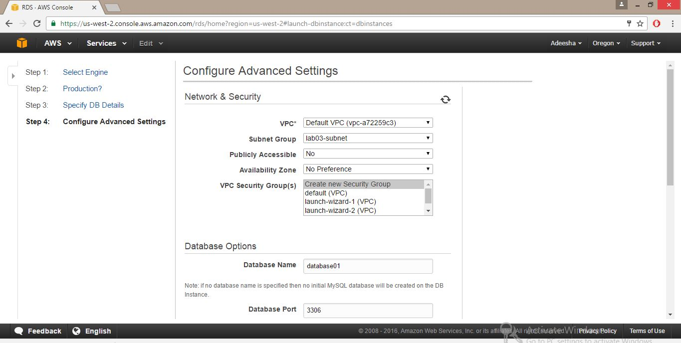

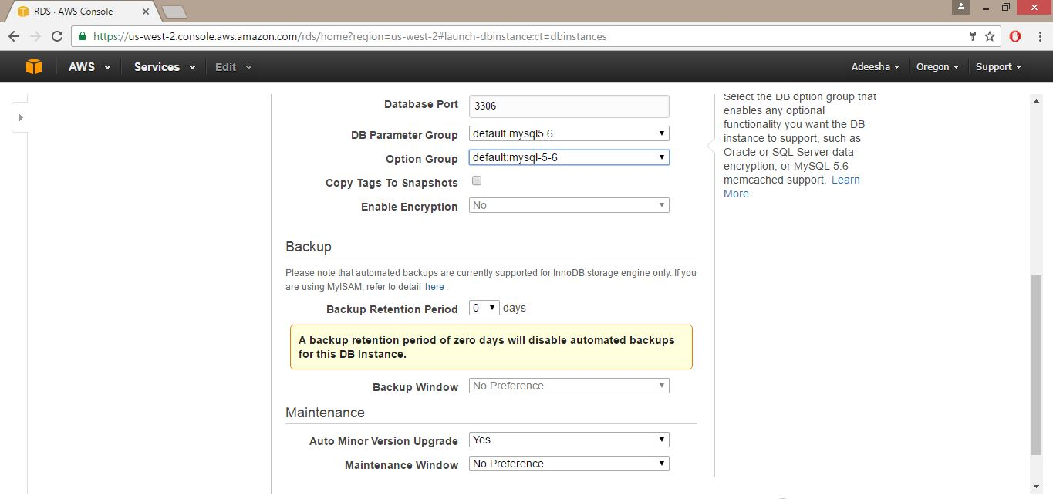

* **Step10**

Now our DB instance is created. Then Click view DB instance button.

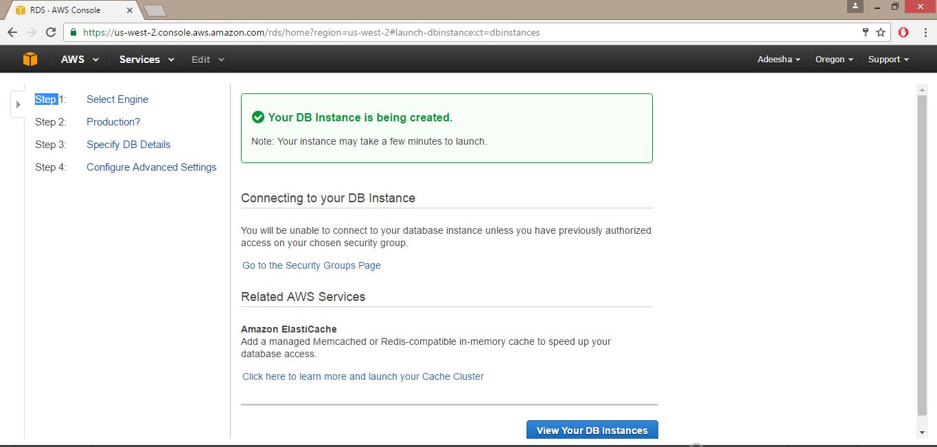

* **Step11**

Created DB instance will be shown as below.

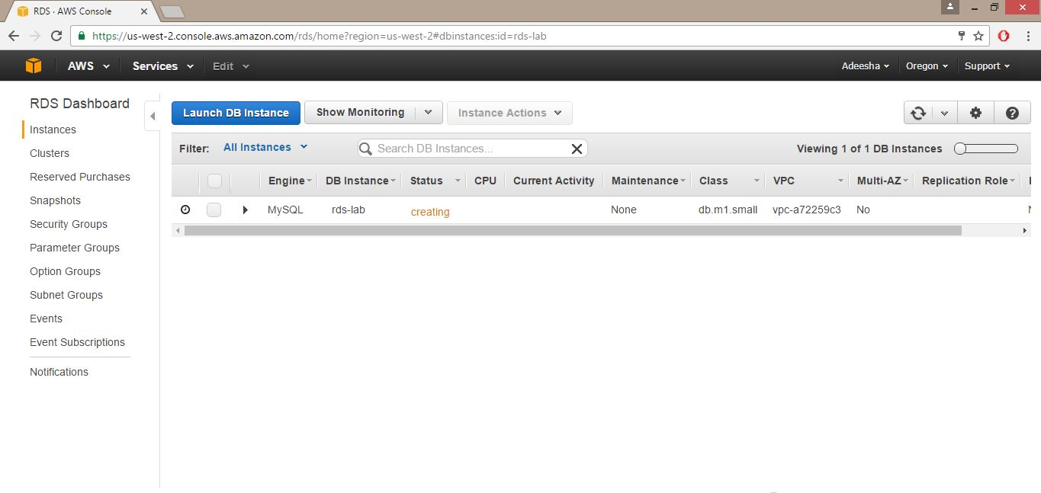

* **Step12**

Now DB Instance is available status.

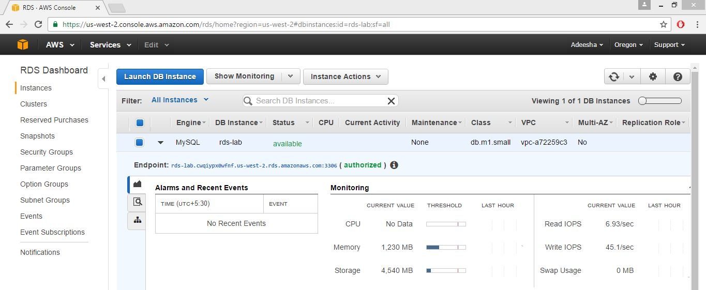

* **Step13**

Then create security group named secure group.

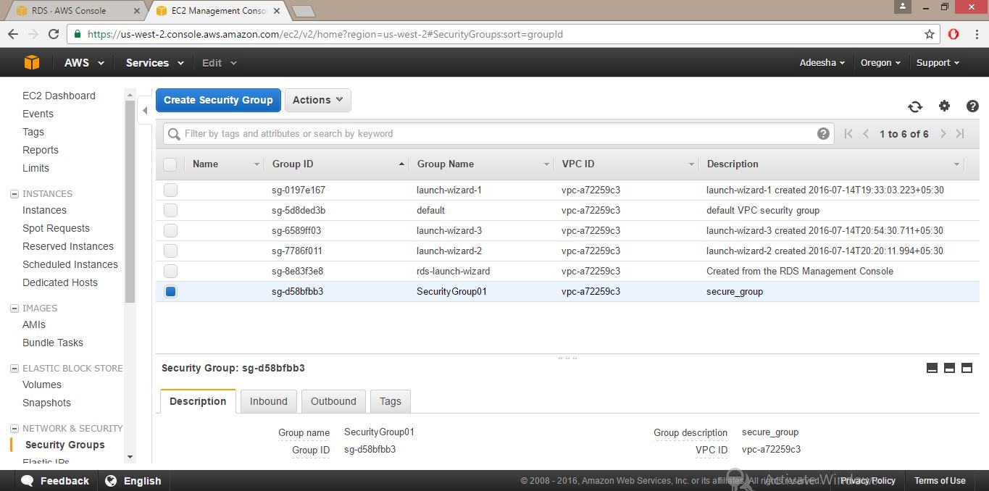

* **Step14**

**To connect to a database on a DB instance using MySQL monitor**

Type this command on a command prompt on a client computer to connect to a database on a MySQL DB instance using the MySQL monitor.

mysql -h <endpoint> -P 3306 -u <mymasteruser> -p

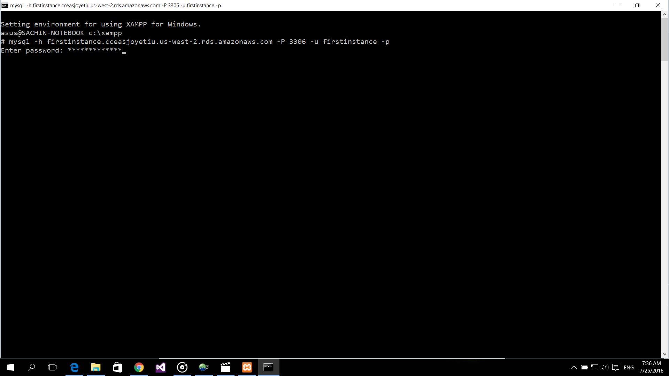

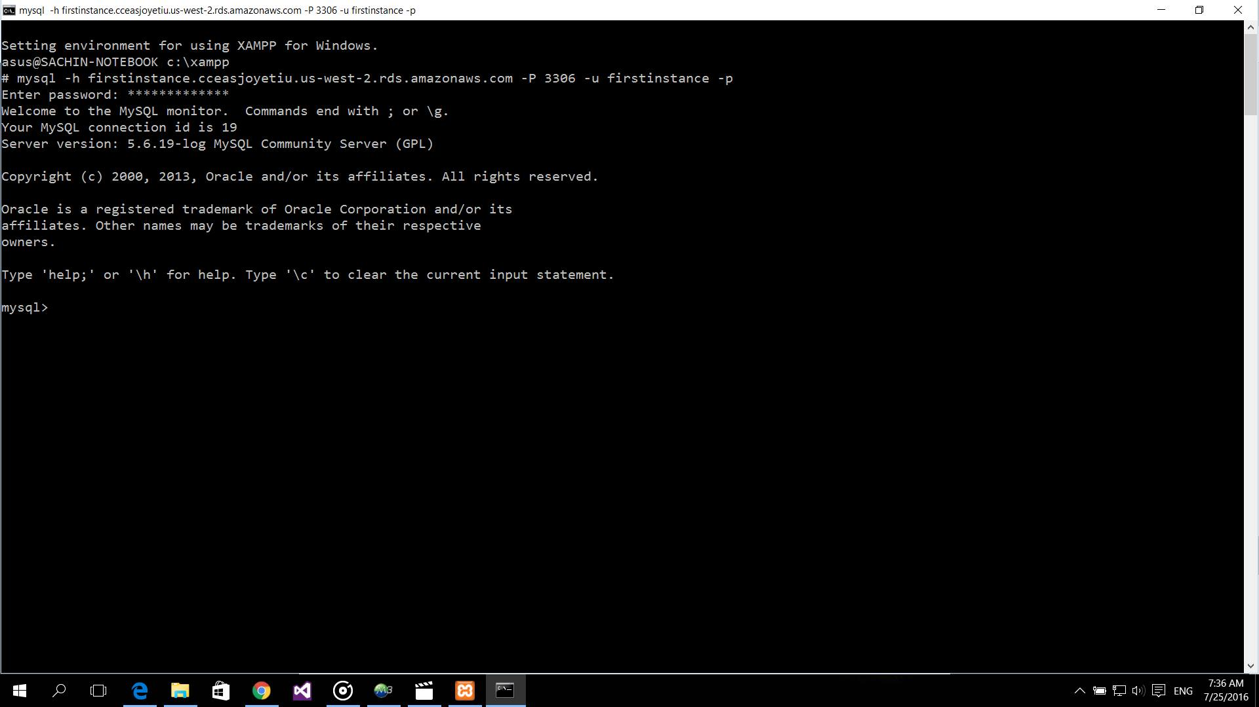

* **Step 15**

Go to instance list. Then select DB instance what we want to delete. Select Instance Actions, and then click Delete from the dropdown menu. Select yes, then deleted DB instance that we previously selected.

